Automated Self-Screening System using Chat Bot
ªDr.L.Arokia Jesu Prabhu, ^{b}B. Siva Reddy
ªAssociate Professor, Department of Computer Science, CMR Institue of Technology,
Hyderabad, Telangana, India
arokiajeruprabhu@gmail.com
^{b}M.Tech 2nd year, Department of Computer Science, CMR Institue of Technology,
Hyderabad, Telangana, India
shivareddyy07@gmail.com
Abstract
Keywords
Azure Health Care Bot,
Chat Bot,
AI Powered Conversational healthcare,
Self-Screening,
Bot Integration

T

his paper depicts creation of an automated screening system by using Microsoft health care bot. The system will have a web interface where the user will take the screening by choosing the applicable option as an answer. The system then analyses the answers provided by the user and performs one of the following actions based upon the result of the screening.
- Allow the user to come to office and send an email.
- Asks the user to stay in the quarantine for 14 days and send the same in email.
- Keeps the user in the waiting state if the user doesn’t know the covid test results

- Introduction
The Health Bot service is a cloud platform that empowers healthcare organization developers to build and deploy their compliant healthcare providers, using AI capabilities and health bots, helping them improve processes and reduce costs. Allows you to give your users smart and personal access to health-related information and interactive experiences
  - Objective
Create an automated screening system that will make use of the Microsoft Health care bot in the backend to create all the required queries - user will select from the options provided.
A workflow will be created based upon all the queries that are prepared as a part of the prerequisites. Based upon the answer provided by the user the workflow will go to the next step. A web application is created by using the NodeJS as developing language. This web application will connect to the Microsoft health care bot in the backend and user will the web application interface to select the options/answers. The system will send emails to the users based on the screening results. The system will save the details of the users and their responses in the database and display them for the administrators for future use.

- Existing System

Chatbots are computer programs that interact with users using natural languages. Existing chat bots are helping in having an interaction with humans and providing the necessary solution for the users.

But chat bots are yet to be implemented in the health care services sector for automation of the human interaction.
  - Literature Review:

ELIZA: The concept of chatbot was introduced by MIT professor Joseph Weizenbaum in 1966. Going forward Turing thought that Weizenbaum created the first chatbot called ELIZA that seemed to make the user believe he was chatting with a real person.

ALICE: ALICE chatbot system which is a summary of Artificial Linguistic Internet Computer Entity and developed by Drs. Richard S. Wallace in 1995. ALICE is a chatbot that focuses on areas such as information representation and algorithm like pattern matching algorithm.

There are researchers who have already done work on the chatbots and published papers like 'Real Time Chat Bots and Their Applications in Human Life' published by V. Krishna sree, C. Kaushik, G. Sahitya and Remalli Rohan provide insights about the various existing chatbots and their history of evaluation, and the applications of various chatbots in different domains. 'AI-based chatbots in customer service and their effects on user compliance' published by Martin Adam, Michael Wessel and Alexander Benlian provided insights about exploration of the chatbots in the fields of the customer service and setting guidelines for the user. 'College Information Chat-Bot System Based on Natural Language Processing' by Dr Raju Shanmugam, Soumya Jena and Vishvaketan Gaur provided the knowledge on how to combine the chatbots along with the web pages and use it across the internet. 'Chatbot for Healthcare System Using Artificial Intelligence' by Lekha Athota, Vinod Kumar Shukla, Nitin Pandey and Ajay Rana provided a path to create a medical chatbot using Artificial Intelligence that can detect the disease and provide the diagnosis of the disease and based upon the details provided by the user before seeing the doctor

Following are the algorithms that are used normally in the chatbots for understating of the inputs by the users and provided the output.
  - Markov Chains:

Markov chains are widely used in text production and Chatbots. They work by determining opportunities to move from one region to another. This model is easy to use and short as it can be easily stored as a matric. These chains do not look at the path taken to achieve a particular situation
  - Naïve Bayes algorithm:

The Naïve Bayes algorithm attempts to break the text into specific categories so that the chatbot can identify the user's intent and reduce the potential range of responses. Since target identification is one of the first and foremost steps in a chatbot conversation, it is important that this algorithm works well.
- Proposed System

The proposed chat bot system will use the combination of the algorithms Markov chains and Naive Bayes Algorithm and provide consistent user experience with increased speed. The system will provide the user interface to do screening, where the user needs to choose one of the applicable options as answer to queries before coming to office on daily basis. The system then informs the respective user along with the administrator of the office on the user status.

The world has changed, and organizations of all kinds are now facing an uncertain future. To prepare for this uncertainty, smart businesses realize that they do not have to carry this weight alone. The adoption of digital tools and technologies is critical to supporting ongoing operations. From setting up early detection systems to restarting workplaces to rethinking how to protect jobs from future disruptions, technology has an important role to play. At Intelex, we have identified three key areas where technology can help.

Bringing employees back to work and operations online safely is a multifaceted exercise - there is no magic bullet or formula to follow. Depending on your organizational make-up and priorities, there will be different challenges to conquer for a successful return to work.
  - Architecture or Proposed Model:

Health Bot Service is a developer cloud platform, built on top of Microsoft Azure. This multi-employer service provides bot health conditions that are different from those of Microsoft partners. The management site gives each partner a detailed control of the configuration and flexibility. Authorized conditions are different from a partner health bot. The health boat event can be embedded within the digital experience of partners

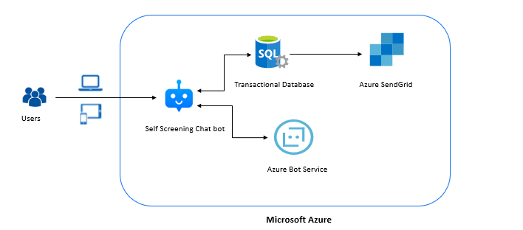
Figure 1: Architecture of the automated screening system

Health Bot uses the Bot Framework under the hood as a messaging and router to deliver messages and returns to the end user. Negotiation skills and medical information are provided by the health Bot service in two ways:
- Integrated third-party content - Microsoft has partnered with reputable content providers to provide comprehensive and reliable medical information.
- Customized chat environments developed with our visual designer tool to meet complex needs. The author can call back the resources using secure and standard authorizations and verification methods.
- Implementation Of The Screening System

Microsoft team had created a Health Care Bot which can be leveraged by the customers to create a screening system that will help to screen the users and allow them to office if the required conditions are satisfied. The Health Bot service simplifies the process of creating a bot that meets the requirements of compliance and control in the health care industry. It does this by providing:
- Expandable management portal
- Set-up options for health care
- Built-in triage and signal monitor
- Integration with Language Understanding Intelligent Service (LUIS) and other understanding services.

Users interact with the chat bot via text or voice in a self-help way. The Health Bot service uses native language understanding (NLP) and artificial intelligence (AI) technology to understand users' intent and provide accurate information.

Azure Health Care Bot has the following properties:

- Interactive AI for Healthcare

The Azure Health Bot service is a cloud service that gives health organizations the ability to build and deploy, visually powerful AI assistants and chatbots that can be used to improve their processes, self-help, and cost-cutting efforts.
- Built-in healthcare strategy

Health Bot comes with built-in AI healthcare AI services, which include a scanner and medical content from well-known industry resources, as well as tuned language comprehension models to understand medical and clinical terms.
- Security and Compliance

The service complies with internationally recognized industry safety and compliance standards such as ISO 27001, 27018, and CSA Gold and GDPR and provides tools that help our partners build solutions that comply with HIPAA.
  - Recall procedures

Before developing an automated self-assessment system an organization needs to work on a memory process to plan how and when employees will return to work to develop a systematic and controlled approach. All employees returning on the same day at the same time may be difficult and perhaps unsafe.

Things to consider include:
- Slowly returning employees to work:
- Use the size or other non-selective features to select. Consider adopting a work assignment or a SUB program when returning employees to a reduced program.
- Determine schedule changes to provide greater protection for employees.
- Creating a plan for employees who are at high risk of infection to return to work:
- Consider letting them work from home or on vacation until they feel comfortable returning.
- Decide additional measures to protect them while working in the area, including isolated work areas, additional PPE as requested, a few days in the office, etc.
- Informing the state unemployment center of reinstated employees. This is a requirement of the state and will help save unemployment taxes for those who choose not to return to work.
- Determining how to deal with employees who are unable or unwilling to return to work.
- Employees who are afraid to return to work.
- Employees with family obligations that impede the ability to return to work.
- Employees who remain incarcerated due to exposure to COVID-19.
  - Initial Setup

We need to provision the following resources in Azure - Azure Bot Service, Database, Send Grid and Webapp. Connection will be established between the web interface and the Azure Health Care Bot Service, Database and Send Grid.

Setting up a channel:

For most channels, you must provide channel configuration information in order to run your bot on the channel. Many channels require your bot to have a channel account, while others, such as Facebook Messenger, require your bot to have a channel-registered application as well.

To set up your Health Bot to connect to the channel, complete the following steps:
- Login to the Health Bot Management Portal
- In the left-hand menu blade, click Channels under Merge
- Select View or Edit channel action you want to open

  - Daily Screening

Every user needs to do screening by using the web interface, where they need to choose one of the applicable options as answer to queries before coming to office on daily basis. The system then informs the respective user along with the administrator of the office on the user status. The screening will be done by using the Web Interface and users need to select from the options provided.
  - Ask the queries

The health bot platform provides tools in the management portal to build your own custom scenarios. Custom scenarios are very powerful and can integrate with external data sources to create engaging experiences for your end user.

By default, the system has inbuilt queries that are provided by the Microsoft template. However, the developers can add new queries or make modifications to the existing queries based upon the requirements. It is advisable to add or modify the queries based upon the protocols that are directed by the government
  - Design and coding

Return message and switch to interrupt advanced settings that control how conditions can temporarily interrupt chat flow. Each situation appears as an image flow of controls. Three types of controls are available in the status editor:
- Communication features visible to the end user, such as Notifications and Statements.
- Flow control devices are not visible to end users but are used to create chat logic.
- Navigation tools such as Zoom, Trace, and Watch are not used during operation, but help the status writer create and edit the status

The queries can be added or modified by selecting the scenario that you want to edit. There are 2 methods to change the queries based upon the knowledge of the developer.
- Visual designer – Click on the ‘designer’ tab on the bottom left (By default designer tab is loaded).
- Java Script – Click on the ‘code’ tab on the bottom left.

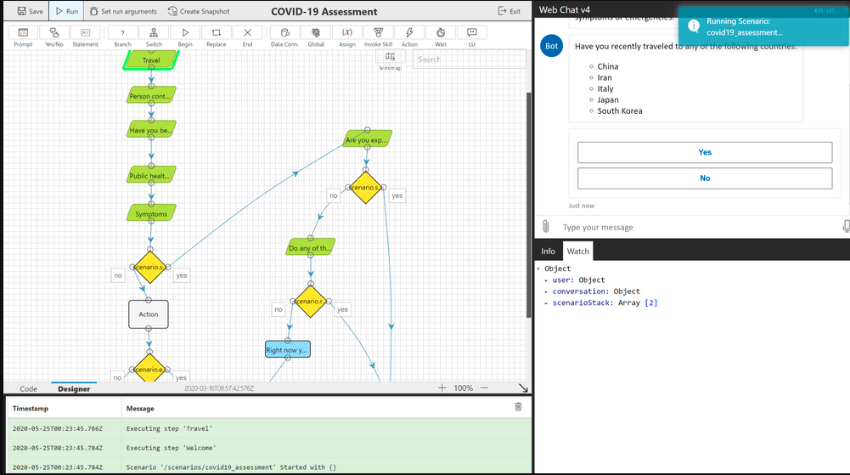
Figure 2: Editor for creation of the chat bot questions

  - Evaluate the user status

The status of the user is evaluated based upon the responses provided by the user like
- Temperature
- Recent travel history – whether the country visited is in travel ban list
- Covid test results
  - Confirm the screening results

Once the evaluation is done then the system will validate whether the user can come to office for work or not and send the screening results over the email to the user.
  - Email responses

After validation of the screening results and determining the status of the user the system will take one of the following actions based upon the screening results.
- Allow the user to come to office and send an email.
- Asks the user to stay in the quarantine for 14 days and send the same in the email.
- Keeps the user in the waiting state if the user doesn’t know the covid test results.
- Results

The Automated Self Screening user interface will look like below once the necessary implementation is completed.

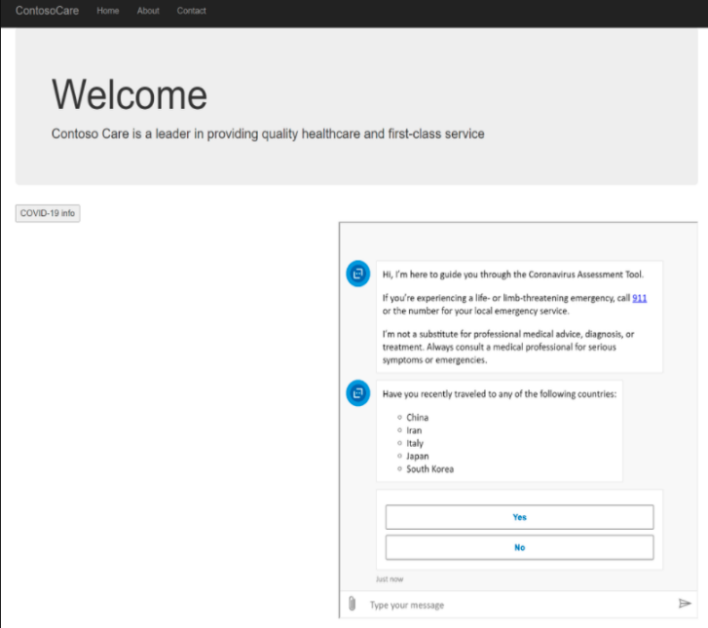
Figure 3: Automated screening system output

As shown in the above screen the users will need to select the options Yes or No or any other responses based upon what is applicable for the respective user
- Conclusion and Future Work

Automated self-screening system built using Microsoft Healthcare Bot, enables organizations to self-screen and assess employees and decide whether it is safe to enter the workplace. The Automated self-screening system will help organizations to:
- Perform self-screening of employees before they physically come to the office
- Generates the pass to the employee and notify the manager and the concerned staff
- Generate insights that will help to respond if a situation arises
- Control the flow of employees in the offices

Future Work:

Creation of an interactive website which will have a user interface for the end users. For development we need to first create an Azure account and create resources like Web App, Azure Health bot and Send Grid.

Once the resources are ready, then the screening questions are designed and developed based upon the requirement.
References
- V.Krishna sree, C.Kaushik, G.Sahitya, Remalli Rohan, "Various Real Time Chat Bots and Their Applications in Human Life", International Journal of Recent Technology and Engineering (IJRTE) ISSN: 2277-3878, Volume-8 Issue-4
- Adam, M., Wessel, M. & Benlian, A. AI-based chatbots in customer service and their effects on user compliance. Electron Markets 31, 427–445 (2021). https://doi.org/10.1007/s12525-020-00414-7
- Daniel, Gwendal & Cabot, Jordi & Deruelle, Laurent & Derras, Mustapha. (2020). Xatkit: A Multimodal Low-Code Chatbot Development Framework. IEEE Access. PP. 1-1. 10.1109/ACCESS.2020.2966919.
- Shanmugam, Dr Raju & Jena, Soumya & Gaur, Vishvaketan. (2020). College Information Chat-Bot System Based on Natural Language Processing. Xi'an Dianzi Keji Daxue Xuebao/Journal of Xidian University. 14. 825-831. 10.37896/jxu14.5/086.
- Adithya Bhawiyuga, M. Ali Fauzi, Eko Sakti Pramukantoro, Widhi Yahya, “Design of E-Commerce chat robot for automatically answering customer question” , International conference on sustainable information engineering and technology, pp. 159-162, 2017.
- Joseph Weizenbaum, “ELIZA: A computer program for the study of natural language communication between man and machine”, common ACM, pp. 36-45, 1996
- Sam Brown, Nikita Pitliya “Setting Up Your COVID-19 Healthcare Bot” which helps us to understand the AI powered health care bot".
- Nikita Pitilia, Julian Soh , Joe Karasha, Han Zhang,Greg Beaumont and Srini Surendranath , “Back to Work” Solution Template using Microsoft Healthcare Bot in Azure" https://cdn-assets.inwink.com/aa214890-4a50-4919-bd01-792a96269ba2/c283f924-813f-4a0d-83ba-61846a1c4078
- Almalki M, Azeez F. Health Chatbots for Fighting COVID-19: a Scoping Review. Acta Inform Med. 2020;28(4):241-247. doi:10.5455/aim.2020.28.241-247
- Battineni, Gopi, Nalini Chintalapudi, and Francesco Amenta. 2020. "AI Chatbot Design during an Epidemic like the Novel Coronavirus" Healthcare 8, no. 2: 154. https://doi.org/10.3390/healthcare8020154
- L. Athota, V. K. Shukla, N. Pandey and A. Rana, "Chatbot for Healthcare System Using Artificial Intelligence," 2020 8th International Conference on Reliability, Infocom Technologies and Optimization (Trends and Future Directions) (ICRITO), 2020, pp. 619-622, doi: 10.1109/ICRITO48877.2020.9197833.
Author’s Biography
Dr.L.Arokia Jesu Prabhu completed his B.Tech.,(IT) from Anna University, Chennai, M.Tech.,(CIT) from M.S.University, Tirunelveli , PhD(ICE - CSE) from Anna University, Chennai in the year 2020. He has 15 years of experience in teaching, research and Industry. He is a Life Member of the International Association of Engineers (IAENG), Computer Science Teachers Association (CSTA), and World Academy of Science, Engineers and Technology (WASET), International Association of Engineers (IAENG). He has published more than 24 papers in conferences and reputed journals during last 3 years. He acted as reviewer in reputed Journals and Conferences like Biocybernetics and Biomedical Engineering – Elsevier, International journal of Imaging Systems – Wiley, International Journal of Ad-hoc and Ubiquitous Computing – Inder-science, International Journal of Intelligent Networks – Kei. Currently he is doing research and development work in the area of Artificial Intelligence, Machine Learning, and Cloud.
B Siva Reddy completed his B.Tech., (IT) from Laki Reddy Bali Reddy College of Engineering, Mylavaram , Andhra Pradhesh, and he is currently pursuing his M.Tech in the branch of CSE from CMRIT College of Engineering. He is currently working as a software engineer and works on the DevOps technologies.

